B.Tech. BCSE497J – Project-I
DEADLINE-AWARE VIDEO SUMMARISATION WITH AN SLA-CONSTRAINED, COST-AWARE SCHEDULER
Submitted in partial fulfillment of the requirements for the degree of
Bachelor of Technology
in
Computer Science and Engineering
by
<< Reg. No. >> | << STUDENT NAME >>
<< Reg. No. >> | << STUDENT NAME >>
<< Reg. No. >> | << STUDENT NAME >>
(names of team members sorted on register number)
Under the Supervision of
<< Project Guide Name >>
<< Designation >>
School of Computer Science and Engineering (SCOPE)
Vellore Institute of Technology, Vellore

October 2026

DECLARATION
I hereby declare that the project entitled “Deadline-Aware Video Summarisation with an SLA-Constrained, Cost-Aware Scheduler” submitted by me, for the award of the degree of Bachelor of Technology in Computer Science and Engineering to Vellore Institute of Technology, Vellore, is a record of bonafide work carried out by me under the supervision of << Project Guide Name >>.
I further declare that the work reported in this project has not been submitted and will not be submitted, either in part or in full, for the award of any other degree or diploma in this institute or any other institute or university.

Place : Vellore
Date : ______________
Signature of the Candidate

CERTIFICATE
This is to certify that the project entitled “Deadline-Aware Video Summarisation with an SLA-Constrained, Cost-Aware Scheduler” submitted by << Student Name (Reg. No.) >>, School of Computer Science and Engineering, Vellore Institute of Technology, Vellore, for the award of the degree of Bachelor of Technology in Computer Science and Engineering, is a record of bonafide work carried out by them under my supervision, as per the VIT code of academic and research ethics.
The contents of this report have not been submitted and will not be submitted either in part or in full, for the award of any other degree or diploma in this institute or any other institute or university. The project fulfills the requirements and regulations of the University and in my opinion meets the necessary standards for submission.

Place : Vellore
Date : ______________
Signature of the Guide
Internal Examiner External Examiner
<< Head of the Department >>
Computer Science and Engineering

ACKNOWLEDGEMENTS
I am deeply grateful to the management of Vellore Institute of Technology for providing me with the opportunity and the resources to undertake this project.
My sincere thanks to Dr. Jaisankar N, the Dean of the School of Computer Science and Engineering, for his unwavering support and encouragement throughout the course of this work.
I express my profound appreciation to << Head of the Department >>, the Head of the Department, for the insightful guidance and the continuous support extended to the project team.
I am immensely thankful to my project guide, << Project Guide Name >>, for the dedicated mentorship and the invaluable feedback that shaped this work. The patience and the questions asked at every review are the reason several comfortable assumptions in this project were measured rather than believed.
Finally, I thank my family and my friends for their steady encouragement during the course of this project.

<< Name of the Candidate >>

TABLE OF CONTENTS
Right-click and choose Update Field to build this list.

LIST OF FIGURES
Right-click and choose Update Field to build this list.

LIST OF TABLES
Right-click and choose Update Field to build this list.

LIST OF ABBREVIATIONS
API Application Programming Interface
ASR Automatic Speech Recognition
CLIP Contrastive Language-Image Pre-training
CPU Central Processing Unit
DFD Data-Flow Diagram
EMA Exponential Moving Average
FAISS Facebook AI Similarity Search
GPU Graphics Processing Unit
HMAC Hash-based Message Authentication Code
JWT JSON Web Token
KTS Kernel Temporal Segmentation
LLM Large Language Model
OCR Optical Character Recognition
OTP One-Time Password
REST Representational State Transfer
SLA Service-Level Agreement
SLO Service-Level Objective
SQL Structured Query Language
TRL Technology Readiness Level
UML Unified Modelling Language
VIT Vellore Institute of Technology

SYMBOLS AND NOTATIONS
c(x) predicted execution time for an input of x minutes, in seconds
a fixed-overhead term of the execution-cost model, in seconds
b per-input-minute rate of the execution-cost model
n, Σx, Σy, Σxx, Σxy the five running sums from which the affine fit is recovered
T the wall-clock budget, or deadline, allowed for a job
τ Kendall rank correlation coefficient
ρ Spearman rank correlation coefficient

ABSTRACT
A recorded lecture is cheap to produce and expensive to watch. A student who needs one answer from a three-hour tutorial has no way to reach it except to sit through the tutorial. Automatic video summarisation addresses this, but the systems that do it share a practical flaw: they run a fixed set of models and finish whenever they finish. On a long lecture that can mean hours of processing, and the user is given no estimate before committing to the wait.
This project treats the deadline as an input rather than an outcome. It builds a seven-stage multimodal pipeline — ingest, transcribe, vision, fuse, understand, index and highlight — and places in front of it a scheduler that keeps, for every available hardware class, an execution-cost model of the affine form c(x) = a + b·x, where x is the length of the input in minutes. The model is fitted online from completed jobs in constant work per job, using five running sums, and it is used before a job starts to choose the cheapest hardware class predicted to finish inside the budget. Where no class can, the shortfall is reported before the run begins instead of discovered after it.
Over 31 recorded runs the scheduler met its budget on 64.5% of jobs, against 6.5% for a fixed, highest-fidelity configuration. The comparison is qualified in Chapter 7: counterfactuals computed from the measured per-minute costs suggest that always choosing the largest class would have met the budget on 71.0% of the same jobs, so the scheduler's contribution is properly described as comparable attainment at lower cost rather than higher attainment. A 11.4-minute lecture completes in 159.2 s, about 4.3× faster than real time.
The summarising model itself is evaluated against human agreement rather than F1 alone, following the protocol of Otani et al. Under 5-fold cross-validation over 75 videos it reaches F1 0.262 on TVSum, against a human agreement of 0.260 and a random baseline of 0.166. On SumMe its rank correlation is close to chance, and the report says so.
The system is implemented in 23,820 lines across 89 source files, is covered by 190 automated tests, and is deployed with authentication, per-tier allowances and payment integration working against live provider APIs.

CHAPTER 1

INTRODUCTION

1.1 Background
Lecture capture, recorded tutorials and conference talks have made long-form educational video abundant. The economics of consuming it have not improved at the same rate: a video is a linear medium, and the only index into it most platforms provide is a scrub bar. A learner who wants to know whether a three-hour SQL tutorial covers window functions, and at what minute, must either watch it or guess.
Automatic video summarisation has been studied for over a decade. Classical work segments a video into shots and scores each for importance, producing a shorter video. More recent systems transcribe the audio and pass the transcript to a language model, producing text. Both lines of work optimise for the quality of the summary. Neither treats the time taken to produce it as a quantity the user is entitled to know in advance.
That omission matters in practice. The stages of a multimodal pipeline do not cost the same: speech recognition and vision dominate, and both scale with the length of the input. On ordinary hardware a long lecture can take longer to process than to watch, which defeats the purpose. The hardware a job runs on, and the fidelity of the models it uses, are therefore not implementation details but the main levers available for delivering a result in a usable time.

1.2 Motivations
Three observations motivated this work.
A result that arrives after an unknown delay is hard to plan around. A user deciding whether to submit a three-hour video needs an estimate before committing, not a progress bar afterwards.
The cost of a job is predictable in a way that is easy to exploit. Execution time on a given machine is close to affine in the length of the input: a fixed overhead for setting up models, plus a rate per minute of material. If that relationship is learned, the finishing time can be predicted before the job starts.
Choosing the fastest available machine wastes the deadline. If a smaller and cheaper machine also finishes in time, the headroom bought by the larger one is paid for and never used. The interesting objective is the cheapest configuration that still keeps the promise.

1.3 Scope of the Project
The project delivers a working web application and the scheduler behind it. In scope: ingestion from a link or an upload; transcription with automatic language detection; scene detection, keyframe extraction and on-screen text recognition; alignment of speech to scene; a language-model pass that produces a chaptered explanation, a quiz, flashcards, a mind map and a practice set; a searchable index that answers questions with citations back to the moment in the video; a highlight reel; authentication and per-tier allowances; and the scheduler that predicts, routes and calibrates.
Out of scope: training new speech or vision models — these are used as interchangeable components; real-time or live-stream processing; and a multi-tenant production deployment with its own hardware fleet. The scheduler is designed for heterogeneous worker classes, and is exercised here across classes emulated on one machine, which Chapter 7 states as a limitation of the evidence rather than of the design.

CHAPTER 2

PROJECT DESCRIPTION AND GOALS

2.1 Literature Review
Each of the works below was read in full. They fall into three groups: summarisation quality, runtime prediction, and deadline-aware scheduling. The project sits at the intersection of the second and third, and adopts the evaluation protocol of the first.
Table 1 Summary of the literature reviewed
Source | Contribution | Limitation for this problem
Potapov et al., ECCV 2014 (KTS) | Kernel temporal segmentation of a video into shots, with category-specific importance scoring. | Segmentation and scoring only; no notion of a processing budget.
Otani et al., CVPR 2019 | Shows that F1 on TVSum and SumMe can exceed human agreement while ranking segments no better than chance; proposes rank correlation. | An evaluation critique, not a system. Its protocol is adopted in Chapter 7.
Radford et al., ICML 2023 (Whisper) | Weakly supervised speech recognition robust across languages and accents. | A component. Its cost scales with audio length, which is what the scheduler must predict.
Deneke et al., ICME 2014; FastTTPS | Predict video transcoding time by linear regression on video characteristics; FastTTPS reports R² = 0.988. | Prediction is not used to choose between machines of differing cost under a deadline.
US 2014/0229221 A1 | Estimates job duration from prior executions across several instance pools and selects the lowest-cost pool that finishes before a need-by time. | Cloud batch compute. Duration is modelled as proportional to input size, with no explicit fixed-overhead term, and model fidelity is never traded to keep the deadline.
Romero et al., USENIX ATC 2021 (INFaaS) | Selects model variant and hardware architecture jointly under latency, accuracy and cost objectives. | Per-query inference serving, where cost does not scale with the length of the input; decisions are made in milliseconds.

2.2 Research Gap
Runtime prediction and deadline-aware placement both exist, but in different literatures and for different workloads. The transcoding work predicts duration and stops there. The cloud-scheduling work places jobs against a deadline but models duration as proportional to input size, without a fixed-overhead term, and does not consider lowering the fidelity of the computation as an alternative to missing the deadline. The inference-serving work chooses model and hardware together, but for single queries whose cost does not grow with an input length. The summarisation literature considers neither.
The gap this project addresses is a single system that maintains a per-hardware-class execution-cost model with an explicit fixed term and a per-input-minute rate, fits it online from completed jobs, routes each job to the cheapest class predicted to meet its deadline, explores unmeasured classes only where the deadline cannot be broken, and reports an unreachable deadline before the job starts. A prior-art search carried out before filing is reported in Section 7.6; it found that the broad form of this claim appears anticipated, and that what remains distinct is narrower than it first appeared. That finding is stated here rather than omitted.

2.3 Objectives
Implement the seven-stage pipeline end to end, from a link or an upload to a chaptered explanation, transcript, quiz, mind map and practice set.
Maintain an execution-cost model per hardware class, of the form c(x) = a + b·x, fitted online from completed jobs in constant work per job.
Route each submitted job to the cheapest class predicted to meet its wall-clock budget, and declare an unreachable budget before the job starts.
Explore classes that are unmeasured or thinly measured, but only where the exploration itself is predicted to keep the deadline.
Resume a part-completed run from cached stage artefacts rather than recomputing it, and exclude such runs from calibration.
Evaluate the summarising model against human agreement on TVSum and SumMe, reporting rank correlation beside F1.
Deliver the whole as an authenticated web application with per-tier allowances.

2.4 Problem Statement
Let a job be a video of length x minutes submitted with a wall-clock budget T seconds. Let K be the set of available hardware classes, each class k having a price rate pₖ and an execution-cost model cₖ(x) = aₖ + bₖ·x estimated from that class's own completed jobs. The routing problem is:
minimise pₖ · cₖ(x) over k ∈ K, subject to cₖ(x) ≤ T
with two departures from the textbook form. First, the coefficients aₖ and bₖ are not given; they are estimated from the class's own history, and the estimate must be refused as not yet credible when the history is too short or too narrow in the range of lengths seen. Second, when the feasible set is empty the problem has no solution in the stated form, and the system must still act: it selects the fastest class, which bounds how far the miss goes, and reports the expected overrun before the job starts.

2.5 Project Plan
Table 2 Phases of the project
Phase | Work | Status
1 | Pipeline stages M1–M4: ingest, transcribe, vision, fuse | Complete
2 | Understanding stage M5′, windowed for long inputs | Complete
3 | Index and highlight, M6 and M7; importance model trained and cross-validated | Complete
4 | Scheduler: per-class cost models, routing, calibration | Complete
5 | Web application, authentication, allowances, payments | Complete
6 | Evaluation against human agreement; SLA measurement | Complete
7 | Invention disclosure and prior-art search | Disclosures drafted; filing pending the IPR Cell's formal search
8 | Measured A/B against a fixed largest-class assignment | Not started; identified in Chapter 8 as the next step

CHAPTER 3

TECHNICAL SPECIFICATION

3.1 Requirements

3.1.1 Functional Requirements
FR1 — Accept a video as a link or an uploaded file, and show a predicted finishing time before processing begins.
FR2 — Transcribe the audio, detecting the language automatically rather than assuming English.
FR3 — Detect scenes, extract keyframes and read on-screen text.
FR4 — Align each transcribed sentence to the scene it was spoken over.
FR5 — Produce a chaptered explanation with timestamps, a scene grid, a transcript, a quiz, flashcards, a mind map, a slide deck, an audio overview and an infographic.
FR6 — Extract every problem solved in the video and restate it in any dialect of the same family: MySQL, PostgreSQL, Oracle, SQL Server and SQLite; Python, Java, C++, JavaScript, C# and Go.
FR7 — Answer free-text questions about the video, citing the moment each answer comes from.
FR8 — Authenticate by e-mail one-time code, phone one-time code or Google, and enforce a per-tier allowance.
FR9 — Resume a part-completed run from cached artefacts instead of recomputing completed stages.
FR10 — Record every completed run as an observation and update the routed class's cost model from it.

3.1.2 Non-Functional Requirements
NFR1 — The predicted finishing time must be produced before the job is enqueued, not after it starts.
NFR2 — Updating a cost model must cost constant work per completed job, independent of how many jobs have been seen.
NFR3 — A failure in any single stage must leave the artefacts of the stages that already succeeded, so the run can be resumed.
NFR4 — A failed run must report the provider's actual error, not a generic message.
NFR5 — Session tokens must be signed; one-time codes must be stored hashed and salted; payment callbacks must be verified by HMAC signature.
NFR6 — The interface must be usable at a laptop width and must render correctly in both a light and a dark colourway.
NFR7 — The system must remain correct under its automated test suite before any submission.

3.2 Feasibility Study

3.2.1 Technical Feasibility
Every component the project depends on is available and was exercised during development: speech recognition, scene detection, keyframe embedding, a vector index and an OpenAI-compatible language-model endpoint. The scheduler requires no special infrastructure — its state is a small table of running sums, and its decision is arithmetic over at most a handful of classes. The principal technical risk met during the project was not compute but provider behaviour: free language-model endpoints impose daily quotas, per-request size limits and reasoning-token accounting that silently consumes the output budget. Each of these was reproduced and handled explicitly rather than retried blindly.

3.2.2 Economic Feasibility
Development used free-tier language-model endpoints and a single laptop, so direct cost was negligible. The operating model assumed in the design is that compute is billed per hour and differs by class, which is what makes the cheapest-feasible-class objective meaningful. Section 7.5 gives the cost analysis. Payment integration was implemented and verified against the provider's live test API, so the revenue path is demonstrated rather than assumed.

3.2.3 Social Feasibility
The system addresses a real constraint on learners: time. By making long-form lecture content searchable, answerable and summarised, it serves Sustainable Development Goal 4, Quality Education, particularly for students whose access to live instruction is limited. Two risks were considered. The first is over-reliance: a generated explanation can be wrong, so every answer the system gives is cited back to the moment in the video it came from, allowing the claim to be checked. The second is language exclusion: pinning transcription to English was tried during development, degraded accuracy on code-mixed lectures and made them slower, and was replaced by automatic detection.

3.3 System Specification

3.3.1 Hardware Specification
Table 3 Hardware used for development and measurement
Item | Specification
Development machine | Windows 11, CPU-only, 16 GB RAM
Worker classes modelled | cpu-2core, cpu-8core, cpu-16core (emulated on one machine by constraining the execution plan)
Accelerator | None. GPU classes are supported by the routing logic but were not available for measurement
Storage | Local disk for the stage artefact cache

The three worker classes were exercised on a single machine by constraining each class's execution plan to its own measured cost model. This is a faithful test of the routing logic and of the calibration loop, but it is not a test across physically distinct machines, and Chapter 7 treats it as such.

3.3.2 Software Specification
Table 4 Software stack
Layer | Technology | Role
Front end | Next.js (App Router), React, TypeScript, Tailwind CSS | The three-panel workspace, the entry screen and the studio
API | FastAPI, Pydantic, Uvicorn | Job submission, authentication, quota checks, result serving
Persistence | SQLAlchemy over SQLite | Users, jobs, payments, SLA observations, cost models
Speech | Whisper | Transcription with language detection
Vision | Scene detection, keyframe extraction, YOLO, OCR | What is on the screen, as distinct from what is said
Retrieval | FAISS, sentence embeddings | Cited question answering over passages
Understanding | OpenAI-compatible LLM endpoint (OpenRouter) | Explanation, quiz, flashcards, practice set
Testing | pytest | 190 automated tests

CHAPTER 4

DESIGN APPROACH AND DETAILS

4.1 System Architecture
The system is a pipeline of seven stages with a scheduler in front of it and a feedback path behind it. A submitted job is first priced: for each hardware class the scheduler predicts the total execution time from that class's own cost model, multiplies by the class's rate, and selects the cheapest class whose prediction fits inside the budget. The job is then executed, each stage writing its artefacts to a cache keyed by the content hash of the video. When the job finishes, the measured time is fed back into the routed class's cost model. That loop — predict, route, measure, refit — is the part of the design the project claims as its contribution.
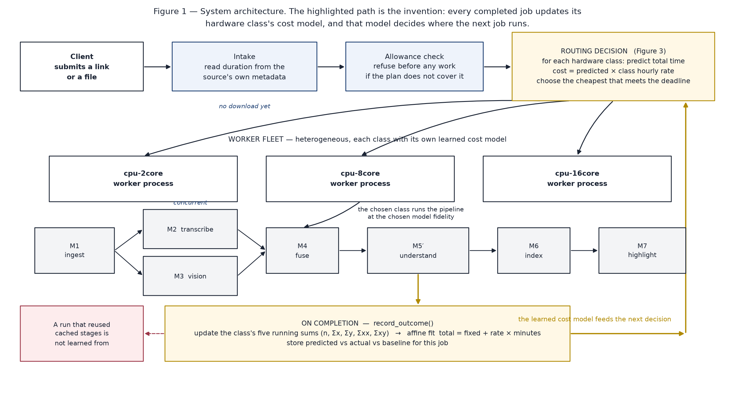
Figure 1 System architecture. The feedback path from completed jobs into the per-class cost models is drawn explicitly, because that loop is what makes the routing adaptive.
Stages M2 and M3 are concurrent: transcription and vision read the same media but share no state, so running them in sequence would waste the larger part of the wall-clock budget. The understanding stage M5′ is windowed — a long video is read in overlapping windows and the partial explanations are reduced — because a single prompt containing a three-hour transcript exceeds every provider's request limit.
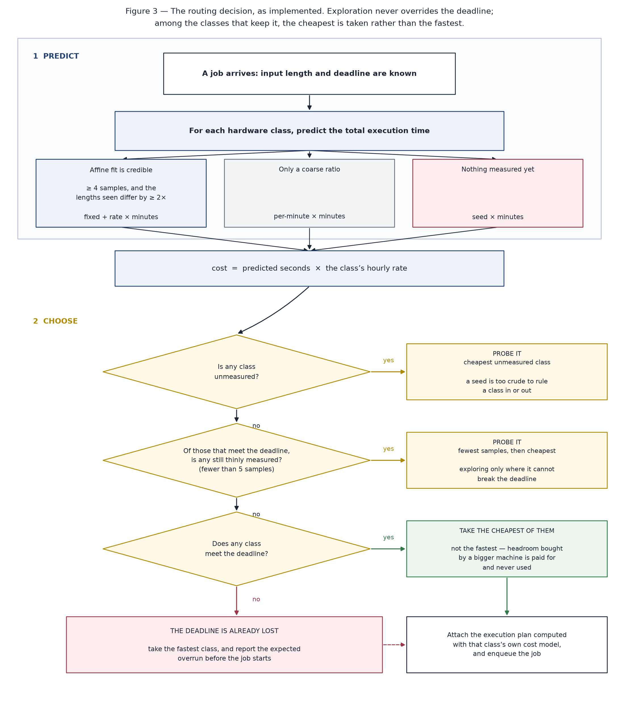
Figure 2 The routing decision, as implemented. Exploration never overrides the deadline; among the classes that keep it, the cheapest is taken rather than the fastest.
The cost model is affine rather than proportional because a proportional model attributes the fixed cost of loading models to the length of the video, which makes short jobs look far more expensive per minute than they are and long jobs cheaper. The fit is maintained from five running sums, so a completed job costs constant work to absorb, and it is refused as not yet credible until at least four jobs have been seen whose lengths differ by a factor of about two — a line through four points that are all the same length carries no information about the slope.
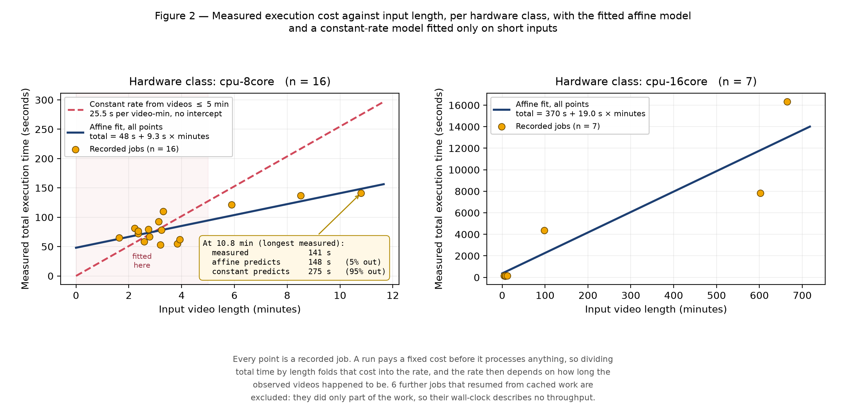
Figure 3 The per-class execution-cost model, fitted from recorded runs. Runs resumed from cache are excluded, and the exclusion is printed on the figure.

4.2 Design

4.2.1 Data Flow Diagram
At the context level the system exchanges data with four external parties: the student, the source of the video, the language-model provider and the payment gateway.
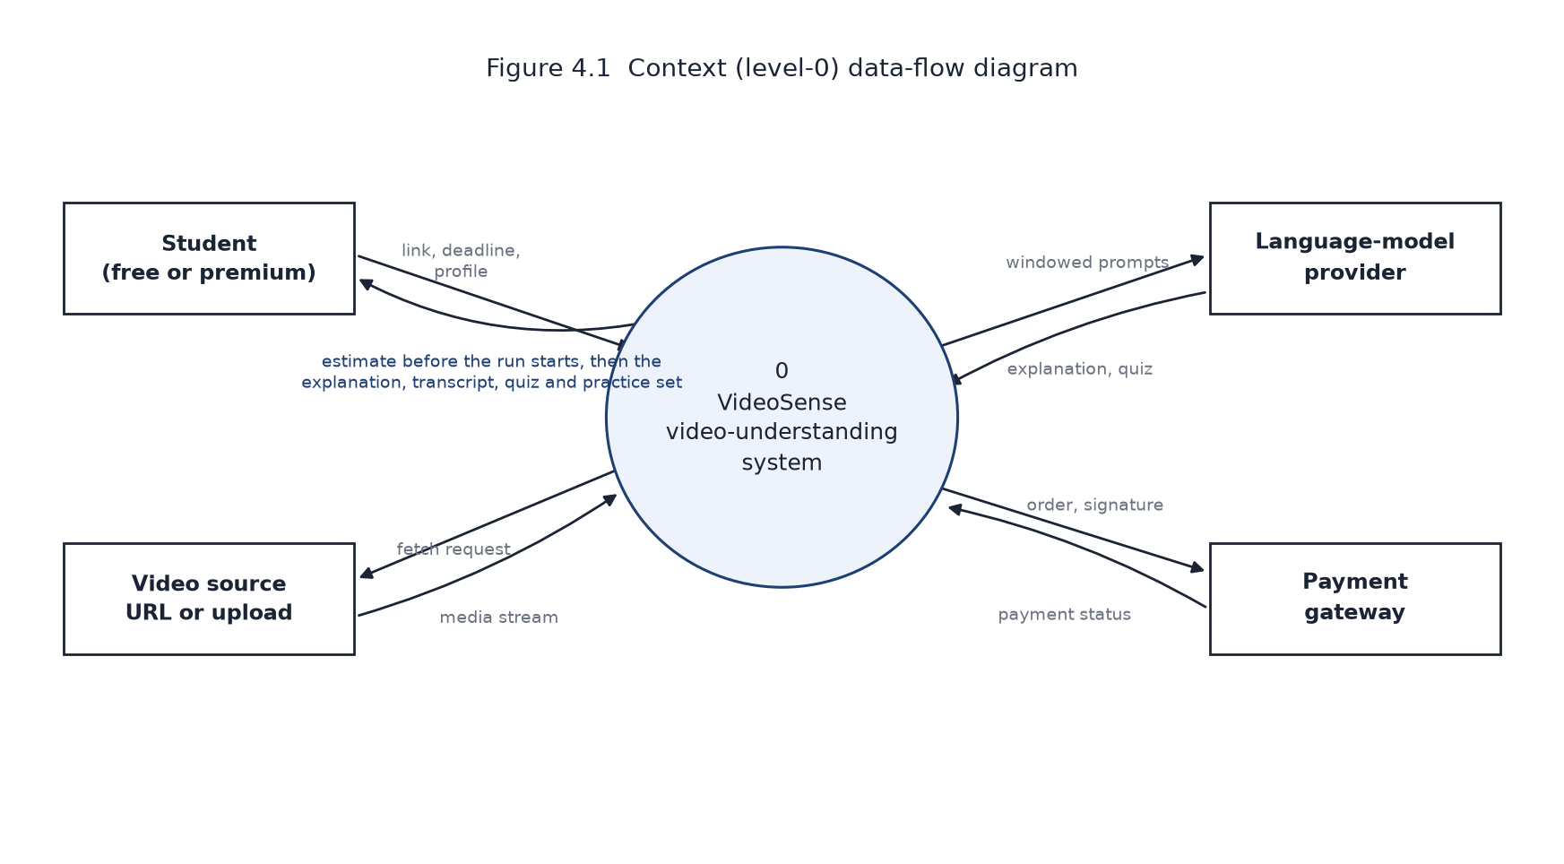
Figure 4 Context (level-0) data-flow diagram.
At level 1 the single process expands into seven, and four data stores appear. The store that matters to the contribution is D4, the per-class cost models: process 2 reads it to route and writes to it after every completed run.
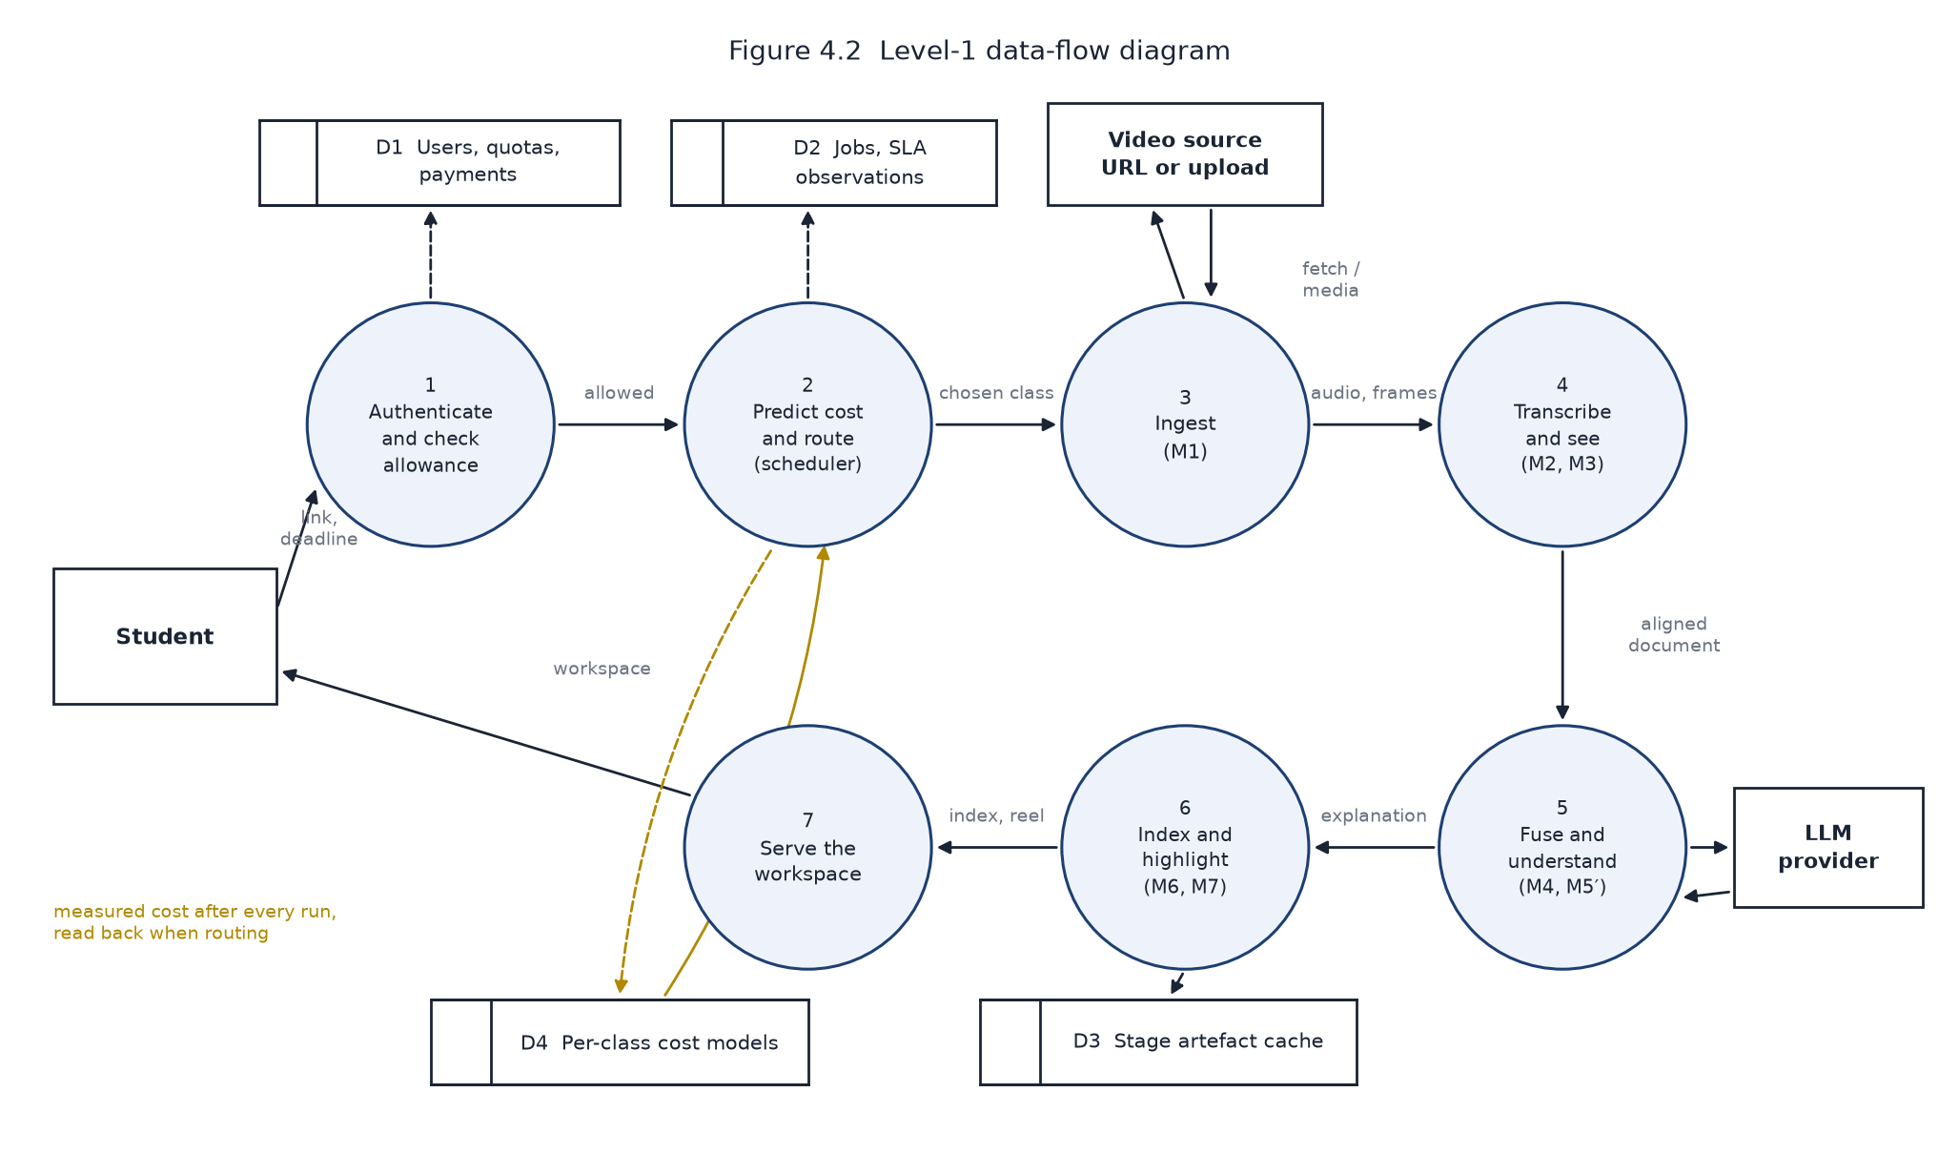
Figure 5 Level-1 data-flow diagram.

4.2.2 Use Case Diagram
Two human actors are distinguished by tier, and three system actors participate. The two shaded use cases are performed by the system itself rather than requested by a user; they are shown because they are where the project's contribution lies.
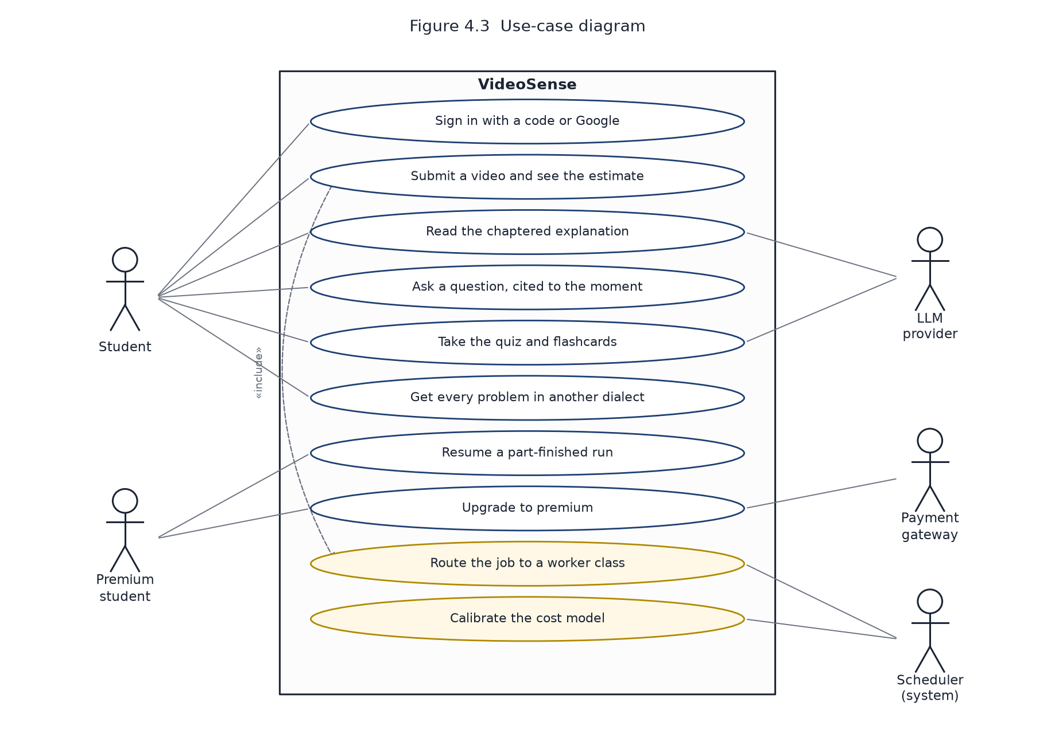
Figure 6 Use-case diagram.

4.2.3 Class Diagram
The persistent model is deliberately small. A Job records what was asked for, what was predicted, where it was routed and what it actually cost. An SlaObservation is the record from which calibration happens; SchedulerCost holds the running sums per class, and CostModel is the in-memory form that answers predict() and observe().
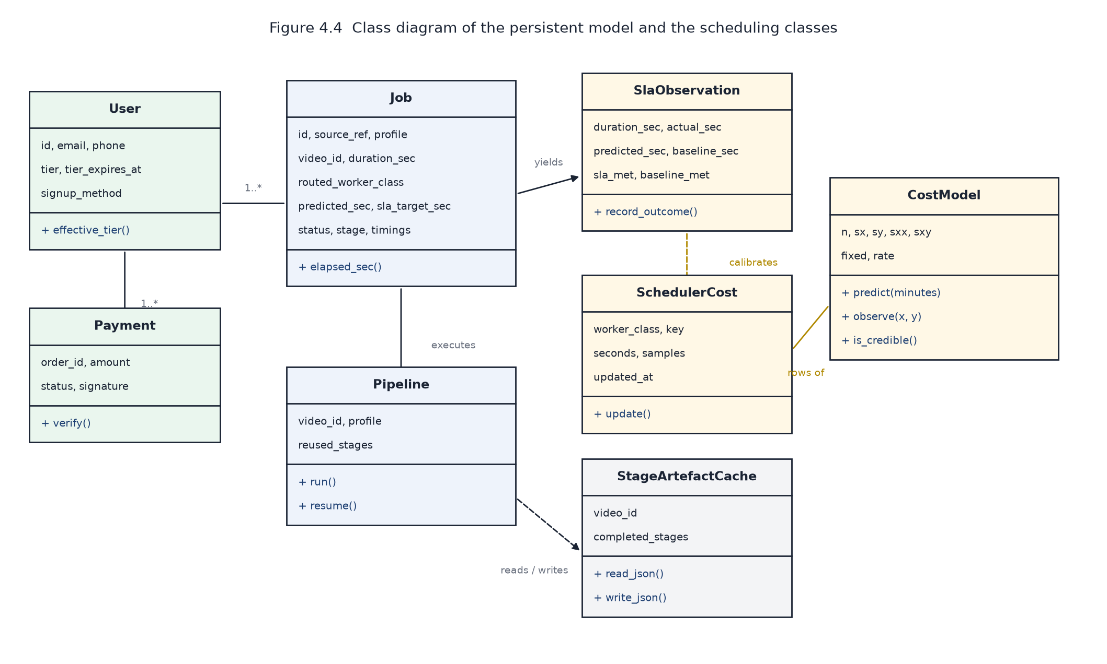
Figure 7 Class diagram of the persistent model and the scheduling classes.

4.2.4 Sequence Diagram
The order below is the one the code follows. The two highlighted messages are the read of the cost models before routing and the update of the affine fit after completion.
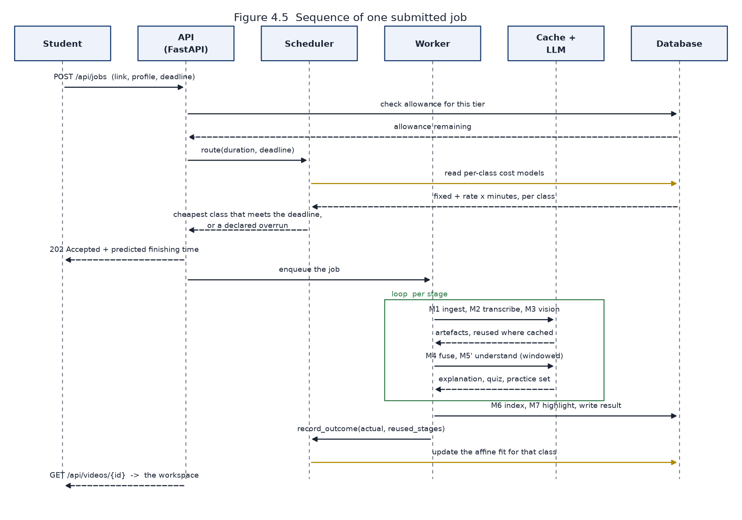
Figure 8 Sequence of one submitted job.

CHAPTER 5

METHODOLOGY AND TESTING

5.1 Module Description
Table 5 The seven pipeline stages and the scheduler
Module | Responsibility | Principal output
M1 Ingest | Fetch the video or accept an upload, probe its duration, extract the audio track. | audio.wav, meta.json
M2 Transcribe | Speech recognition with automatic language detection; long audio is chunked. | transcript.json
M3 Vision | Scene detection, keyframe extraction, object detection and on-screen text. Runs concurrently with M2. | scenes.json, keyframes/
M4 Fuse | Align each transcribed sentence to the scene it was spoken over. | fused.json
M5′ Understand | A language model reads the fused document in windows and writes the explanation, quiz, flashcards and practice set. | understanding.json
M6 Index | Build a FAISS index over passages for cited question answering. | qa_index/
M7 Highlight | Score shots with the trained importance model and cut a reel. | highlight.mp4
Scheduler | Predict per-class cost, route the job, record the outcome and refit. | SlaObservation, SchedulerCost

5.2 Testing
The system is covered by 190 automated tests, all passing at the time of submission. The suite is weighted towards the parts of the system where a silent error would be most damaging: the cost model and the routing decision, where a wrong number produces a plausible but incorrect schedule rather than a crash.
Table 6 Test coverage by area
Area | What is tested
Cost model | Affine recovery from the running sums; refusal to use a fit from too few samples or too narrow a spread of lengths; rejection of a negative slope.
Routing | Cheapest feasible class is chosen, not the fastest; unmeasured classes are probed; exploration never overrides the deadline; infeasibility is declared before the run.
Calibration | Runs resumed from cache do not update the cost model; an implausible real-time ratio is rejected.
Pipeline | Stage artefacts are cached and reused; a failed stage leaves earlier artefacts intact; the real provider error is carried into the failure message.
Understanding | Window planning for long inputs; the fallback overview when a reduce pass fails; empty-window detection.
Identity and quota | Code hashing and expiry; the resend window runs from the last code sent; per-tier allowances; payment signature verification.
API | Schema validation, authentication on every route, quota refusals carrying a usable message.

CHAPTER 6

PROJECT DEMONSTRATION
The screens below are captures of the running application, taken at a fixed window size from a test account so that no personal data appears. The worked example throughout is a 11.4-minute lecture, “Intro to Algorithms: Crash Course Computer Science #13”.

Figure 9 The entry screen, with the four headline figures measured from the system's own records.
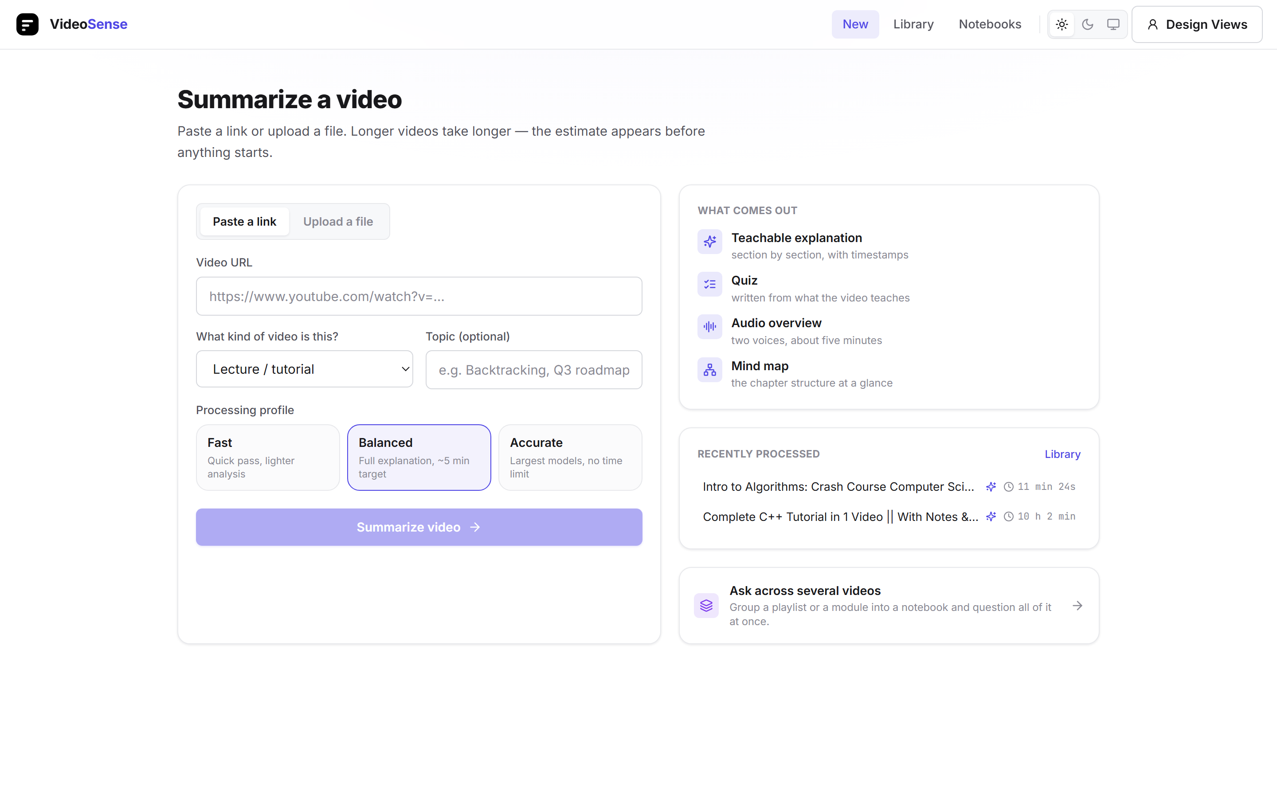
Figure 10 The submission screen. The processing profile is chosen here, and the estimate is shown before the run starts.
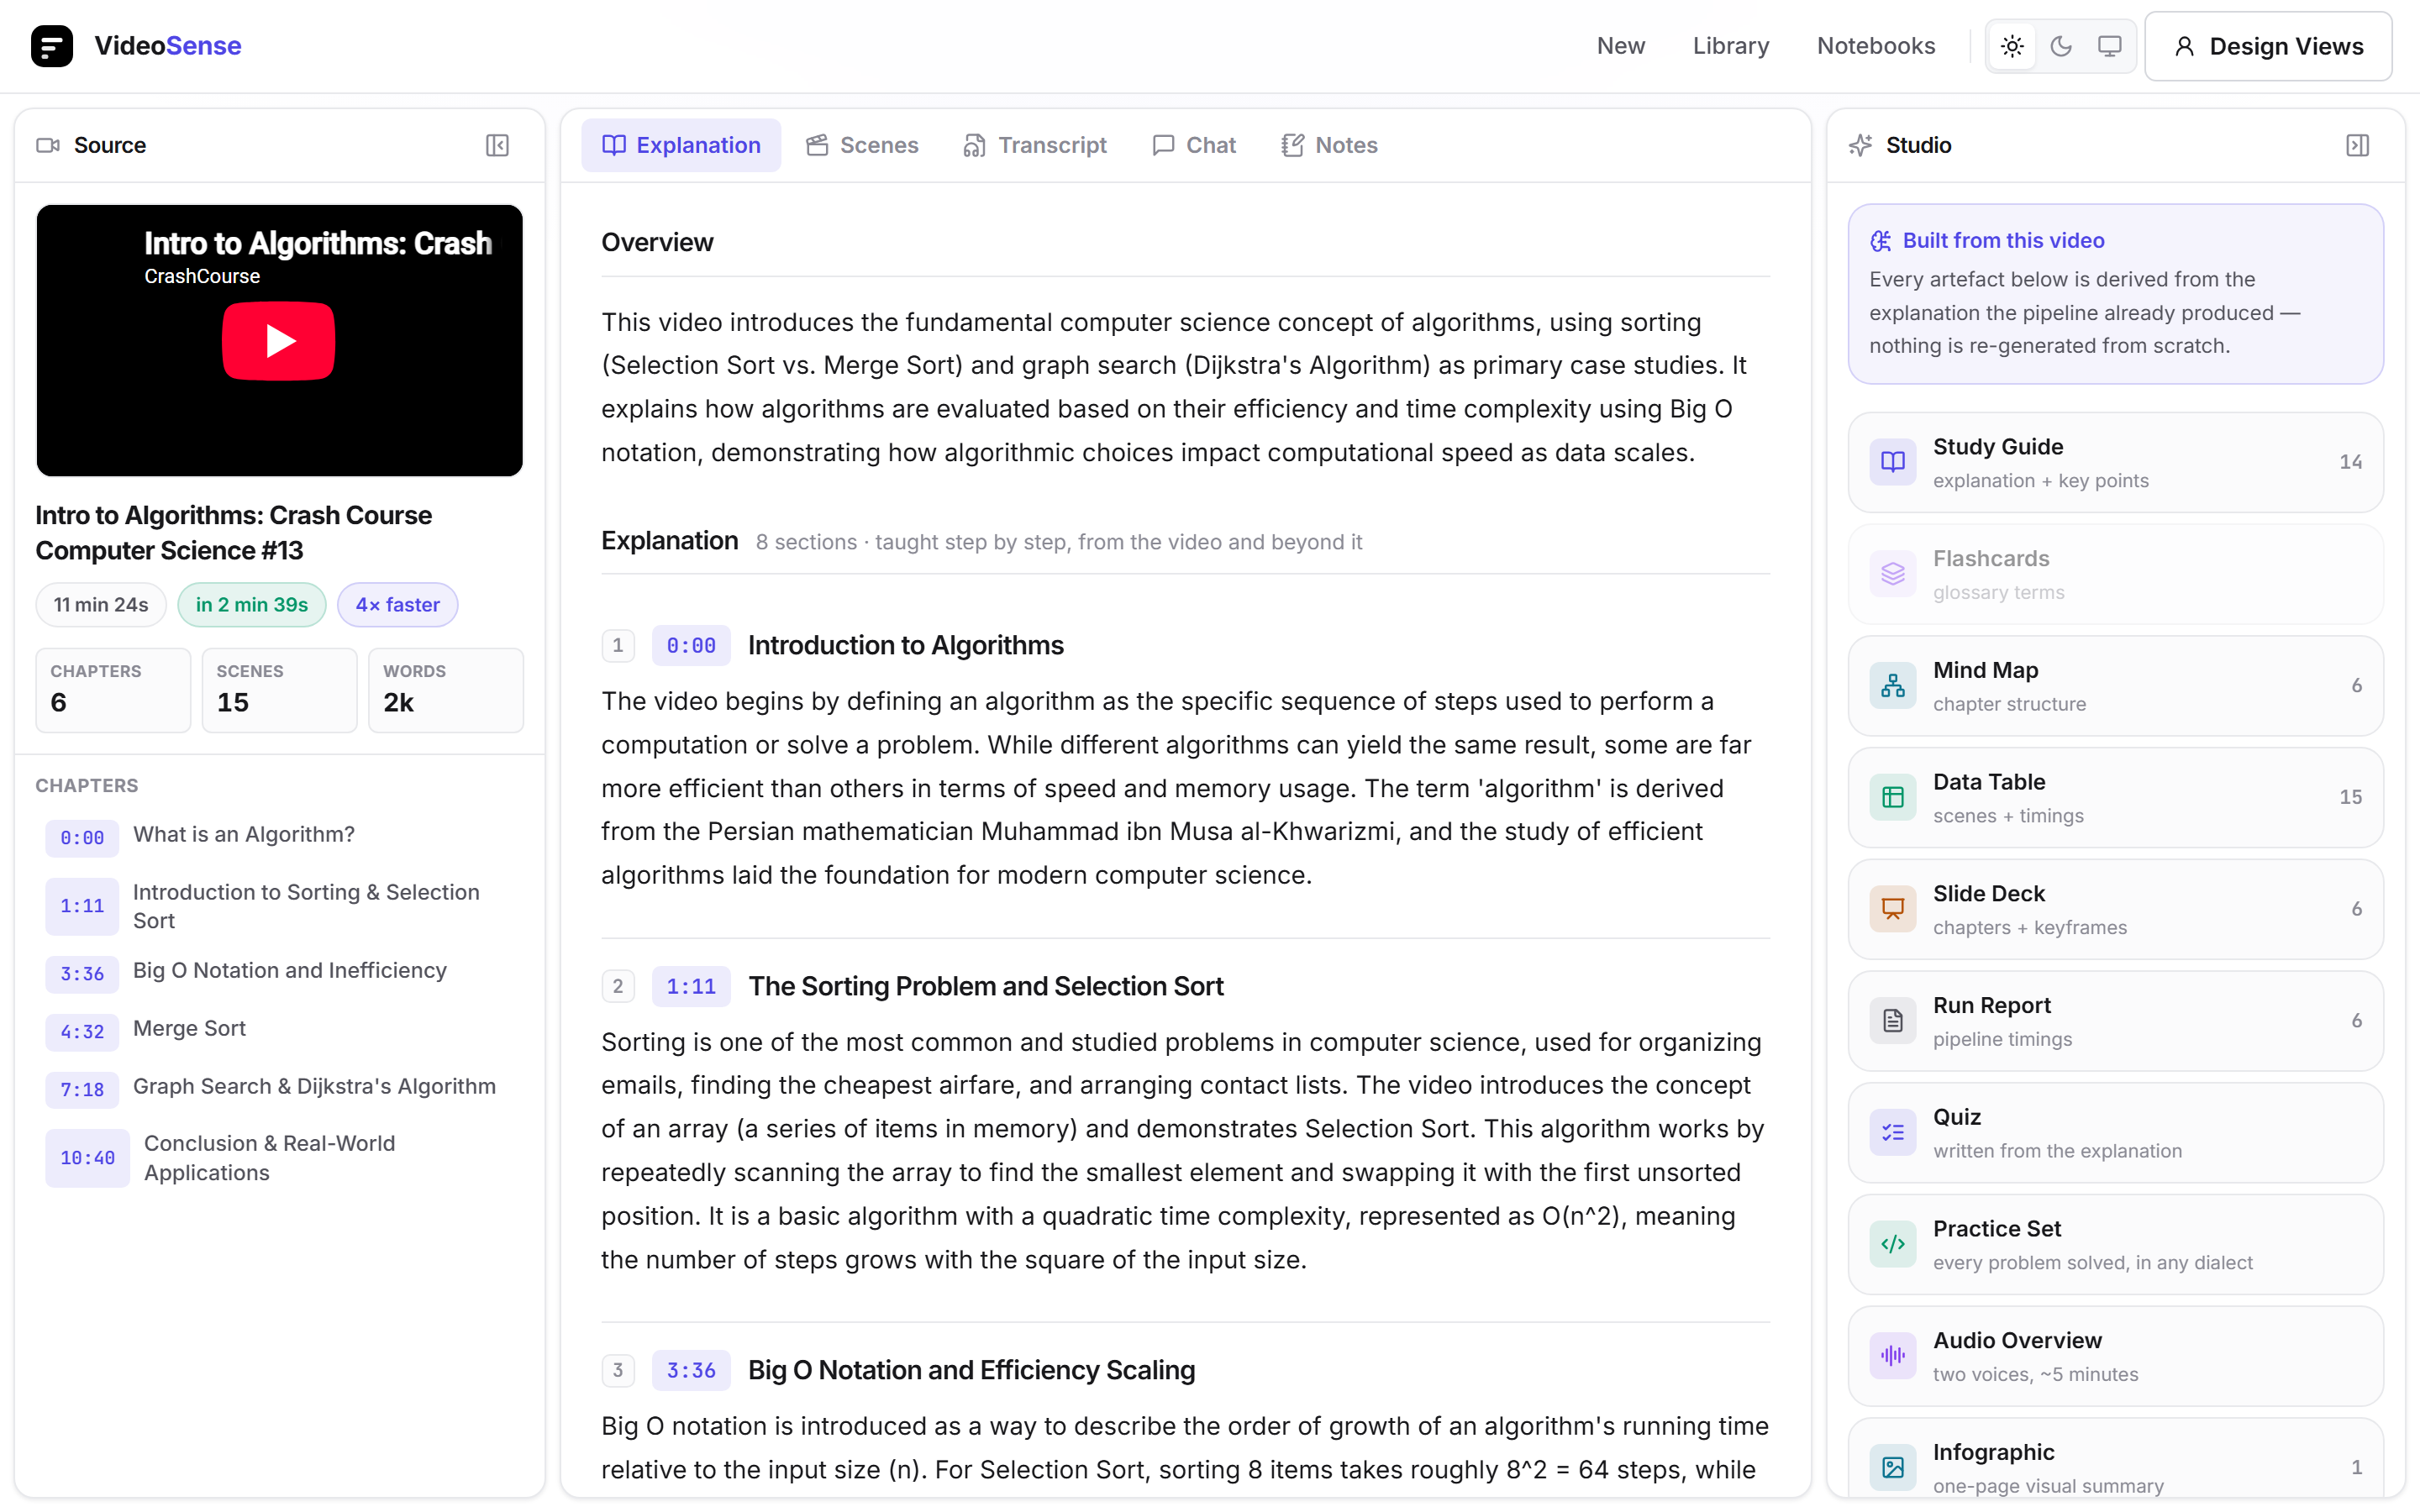
Figure 11 The workspace: source panel, the chaptered explanation, and the studio column of derived artefacts.
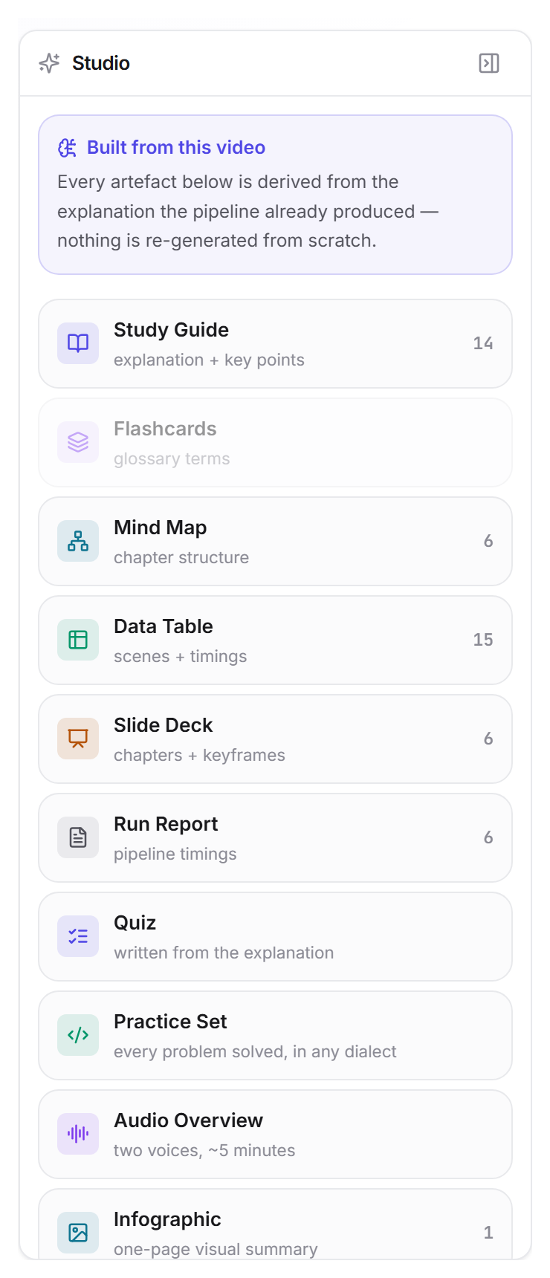
Figure 12 The studio column. Each tile names a derived artefact and the material it was derived from, with the quantity on the right.
Figure captions for these screens correspond to the design representations submitted with the design-registration disclosure; the same captures are used in both documents so that the report and the filing cannot diverge.

CHAPTER 7

RESULT AND DISCUSSION

7.1 Throughput on a Worked Example
The reference run is a 11.4-minute lecture processed end to end on the cpu-16core class. It completed in 159.2 s against a budget of 300 s, which is about 4.3× faster than watching it.
Table 7 Stage timings for the reference run, in seconds
Stage | Seconds | Share of total
ingest | 16.7 | 10.5%
analyze | 69.8 | 43.8%
fuse | 0.1 | 0.1%
summarize | 43.5 | 27.3%
index | 2.9 | 1.8%
total | 159.2 | 100.0%

The distribution is the reason the scheduler exists. Analysis and understanding together account for the large majority of the time, and both scale with the length of the input; fusing and indexing are almost free. A cost model that captures the per-minute rate of the two dominant stages therefore predicts the whole run well enough to route on.

7.2 Deadline Attainment
Over 31 recorded observations the scheduler met its budget on 64.5% of jobs. The fixed-configuration baseline — a static, highest-fidelity plan that never downshifts — met it on 6.5%.
Table 8 Deadline attainment against baselines
Strategy | SLA met | Mean time ÷ budget | Kind
Scheduler (this project) | 64.5% | 4.36 | Measured
Fixed highest-fidelity configuration | 6.5% | 15.30 | Measured
Always cpu-16core | 71.0% | 2.95 | Counterfactual
Always cpu-2core | 51.6% | 8.22 | Counterfactual
Random choice of class | 61.3% | — | Counterfactual

The last three rows must be read carefully, and the project does not claim more from them than they support. They are counterfactuals computed from each class's measured per-minute cost: for every recorded job they ask whether that class's predicted time would have fitted the budget. They therefore assume the cost model is exact. The scheduler's own figure is measured and includes every real-world failure — provider stalls, a reduce pass that had to be retried, a run whose summarise stage took nearly three hours.
Read that way, the honest conclusion is twofold. Against a static configuration that never adapts, the scheduler is decisively better: 64.5% against 6.5%. Against the strongest fixed routing choice — always using the largest class — it is not better on attainment, and the counterfactual suggests it would be worse (71.0%). The scheduler's claim is therefore comparable attainment at lower cost, which Section 7.5 quantifies, and not higher attainment. A direct measured A/B against the always-largest policy has not been run, and is the first item of future work.

7.3 A Limitation in the Budget Policy
Every observation in the table above was taken against a flat budget of 300 s, applied regardless of the length of the video. For an eleven-minute lecture that is a demanding but reachable target. For a ten-hour tutorial it is unreachable by any configuration, and the system correctly declares so before starting. A substantial share of the recorded misses are therefore structural rather than failures of routing. A length-proportional budget would make the attainment figures more meaningful, and is listed in Chapter 8.

7.4 Summarisation Quality
Following Otani et al., F1 alone is not treated as evidence. The table reports F1 beside rank correlation, and beside two reference points computed on the same shards: the agreement between human annotators, and the score of random importance values.
Table 9 Summarisation quality, 5-fold cross-validation over 75 videos
Dataset | Model F1 | Human F1 | Random F1 | Model τ | Model ρ
TVSum | 0.262 | 0.260 | 0.166 | 0.214 | 0.278
SumMe | 0.445 | 0.612 | 0.368 | 0.053 | 0.066

On TVSum the model's F1 is marginally above the human agreement figure (0.262 against 0.260) and well above random (0.166), and its rank correlation of τ = 0.214 indicates it is genuinely ordering segments rather than exploiting the metric. On SumMe the picture is different and worse: F1 of 0.445 sits between random (0.368) and human (0.612), but τ = 0.053 is close to zero, meaning the model is not ranking SumMe shots meaningfully at all. This is exactly the failure mode Otani et al. warn about, and it is reported rather than hidden behind the favourable F1.
F1 for random scores, leave-one-out human agreement, and the averaged annotator target, computed on the same prepared shards. The model rows are 5-fold cross-validated; these are not, because they involve no learning. Absolute F1 is not portable between pipelines - it depends on the feature extractor, the sampling rate and the shot segmentation - so these are the only yardsticks this number can honestly be read against.

7.5 Cost Analysis
The scheduler optimises cost subject to the deadline, so the appropriate measure of its benefit is spend per job, not speed. Using the per-minute costs the system has measured for each class, the cheapest-feasible policy differs from the always-largest policy in that it places a job on a smaller class whenever the smaller class is also predicted to finish in time.
Table 10 Measured per-minute execution cost by class
Worker class | Seconds per video-minute | Samples
cpu-16core | 10.78 | 51
cpu-2core | 30.00 | 50

Two caveats are owed here. The per-class figures were produced on one physical machine with the classes emulated, so they establish that the mechanism works and not what the savings would be on a real fleet. And the affine fit for the largest class is not yet credible by the system's own test — it has seen too few jobs at sufficiently different lengths — so routing currently falls back to the coarser per-minute ratio for that class. The fallback behaving correctly is itself one of the tested properties, but a fuller evaluation needs more jobs at a wider spread of lengths.

7.6 Prior Art and Patentability
Because the scheduler was considered for a patent filing, a prior-art search was carried out before any disclosure was submitted. It is reported here because its result qualifies the novelty claimed in Section 2.2.
The broad form of the claim — learn job duration from past runs, then choose the cheapest machine that still meets a deadline — appears anticipated by US 2014/0229221 A1, which was read in full. The joint selection of hardware and model fidelity is close to INFaaS. Linear regression for media-processing runtime is established in the transcoding literature. What no source was found to describe is the specific combination used here: an explicit fixed-overhead term with a per-input-minute rate, maintained per hardware class from running sums, gated by a credibility test on sample count and length spread, with asymmetric treatment of overruns and improvements, and exploration permitted only where the deadline is predicted to hold.
Invention disclosures for the scheduler and for the interface have been prepared on that basis, with the closest prior art cited in them rather than omitted. The formal classification search remains with the VIT IPR Cell.

CHAPTER 8

CONCLUSION
This project set out to make the time a video-understanding job takes a quantity the user is told in advance rather than discovers afterwards. It does that by learning, for each hardware class, an affine model of execution time against input length, fitting it online from completed jobs at constant work per job, and routing each new job to the cheapest class predicted to meet its budget — declaring the shortfall before the run starts when no class can.
Measured over 31 runs, the scheduler meets its budget on 64.5% of jobs against 6.5% for a static configuration. The 11.4-minute reference lecture completes in 159.2 s. The summarising model matches human-level F1 on TVSum with a rank correlation that confirms it is genuinely ordering segments, and 190 automated tests pass.
Three limitations are stated plainly rather than deferred. The flat budget makes many of the recorded misses structural. The per-class comparison rests on counterfactuals computed from the cost model, not on a measured A/B, and against the strongest fixed policy the scheduler is not better on attainment. And the worker classes were emulated on a single machine, so the cost savings are demonstrated in mechanism rather than in magnitude.
The next steps follow directly from those limitations:
A measured A/B against an always-largest-class policy, on physically distinct machines, replacing the counterfactual in Table 7.2.
A length-proportional budget in place of the flat one, so that attainment measures routing rather than arithmetic.
A second term in the cost model for output configuration — the transcoding literature shows execution time depends on target bitrate as well as duration.
GPU worker classes, which the routing logic already supports and which would widen the spread of costs the scheduler has to reason about.
Completion of the patent filing with the narrowed claim identified by the prior-art search.

CHAPTER 9

REFERENCES
[1] D. Potapov, M. Douze, Z. Harchaoui and C. Schmid, “Category-specific video summarization,” in Proc. European Conference on Computer Vision (ECCV), 2014, pp. 540–555.
[2] M. Otani, Y. Nakashima, E. Rahtu and J. Heikkilä, “Rethinking the evaluation of video summaries,” in Proc. IEEE/CVF Conference on Computer Vision and Pattern Recognition (CVPR), 2019, pp. 7596–7604.
[3] A. Radford, J. W. Kim, T. Xu, G. Brockman, C. McLeavey and I. Sutskever, “Robust speech recognition via large-scale weak supervision,” in Proc. International Conference on Machine Learning (ICML), 2023, pp. 28492–28518.
[4] J. Johnson, M. Douze and H. Jégou, “Billion-scale similarity search with GPUs,” IEEE Transactions on Big Data, vol. 7, no. 3, pp. 535–547, 2021.
[5] F. Romero, Q. Li, N. J. Yadwadkar and C. Kozyrakis, “INFaaS: Automated model-less inference serving,” in Proc. USENIX Annual Technical Conference (ATC), 2021, pp. 397–411.
[6] T. Deneke, H. Haile, S. Lafond and J. Lilius, “Video transcoding time prediction for proactive load balancing,” in Proc. IEEE International Conference on Multimedia and Expo (ICME), 2014.
[7] “Cost-aware scheduling of compute jobs against a need-by time,” U.S. Patent Application US 2014/0229221 A1, Aug. 2014.
[8] “Estimating transcoding duration for scheduling media jobs,” U.S. Patent Application US 2015/0006226 A1, Jan. 2015.
[9] “System for content aware reconfiguration of video object detection,” U.S. Patent 12,469,288.
[10] Office of the Controller General of Patents, Designs and Trade Marks, Guidelines for Examination of Computer Related Inventions (CRIs). New Delhi, India: Government of India, 2025.
[11] Y. Song, J. Vallmitjana, A. Stent and A. Jaimes, “TVSum: Summarizing web videos using titles,” in Proc. IEEE Conference on Computer Vision and Pattern Recognition (CVPR), 2015, pp. 5179–5187.
[12] M. Gygli, H. Grabner, H. Riemenschneider and L. Van Gool, “Creating summaries from user videos,” in Proc. European Conference on Computer Vision (ECCV), 2014, pp. 505–520.

APPENDIX A – SAMPLE CODE
Two extracts from server/scheduler.py: the recovery of the affine fit from the running sums together with the test that decides whether the fit may be used, and the routing decision itself.

A.1 Recovering the Affine Fit and Testing its Credibility
n = stats["fit:n"][0]
sx, sy = stats["fit:sx"][0], stats["fit:sy"][0]
sxx, sxy = stats["fit:sxx"][0], stats["fit:sxy"][0]
if n < 2:
return None

denom = n * sxx - sx * sx
if denom <= 1e-9:
return None
slope = (n * sxy - sx * sy) / denom
intercept = (sy - slope * sx) / n

# x-spread, as max/min cannot be recovered from the sums: use the
# coefficient of variation as a proxy for "these were not all the same".
mean_x = sx / n
var_x = max(sxx / n - mean_x * mean_x, 0.0)
spread_ok = mean_x > 0 and (var_x ** 0.5) / mean_x > (_FIT_MIN_SPREAD - 1) / 3.0

credible = (
n >= _FIT_MIN_SAMPLES
and spread_ok
and slope > 0
and intercept >= -1e-6
)
return CostFit(max(intercept, 0.0), slope, int(n), credible)

A.2 The Routing Decision
# Explore, then exploit - but never at the SLA's expense, and among the
# classes that keep the promise, take the cheapest rather than the fastest.
#
# Choosing the fastest class that meets the SLA wastes the whole point of
# having a deadline: if a smaller, cheaper machine also finishes in time,
# the headroom bought by the larger one is paid for and never used.
#
# A class with no measurements has only a seed estimate, too crude to route
# on or to rule out, so probe it once. Beyond that, pure exploitation is a
# trap: the moment one class wins it takes every job, the others' models go
# stale, and the router is deciding on numbers it can no longer check.
unsampled = [p for p in predictions if p.samples == 0]
within = [p for p in predictions if p.meets_sla]
under_measured = [p for p in within if p.samples < _EXPLORE_MIN_SAMPLES]

by_cost = lambda p: (p.cost, p.predicted_sec, p.worker_class)
by_speed = lambda p: (p.predicted_sec, p.worker_class)

if unsampled:
chosen = min(unsampled, key=by_cost)
elif under_measured:
chosen = min(under_measured, key=lambda p: (p.samples, *by_cost(p)))
elif within:
chosen = min(within, key=by_cost)
else:
chosen = min(predictions, key=by_speed)

